# Identifying Polynomial Functions

Let $n$ be a non-negative integer. A **polynomial function** is a function that can be written in the form

$$f(x)=a_{n}x^{n}+…+a_{2}x^{2}+a_{1}x+a_{0}$$

This is called the general form of a polynomial function. Each $a_{i}$ is a coefficient and can be any real number, but $a_{n}$ $≠0$. Each expression $a_{i}x^{i}$ is a **term of the polynomial function**.

Examples: Identify which functions are polynomial functions.

$f\left(x\right)={ 2x}^{3}∙3x+4$

$g\left(x\right)=-x\left(x^{2}-4\right)$

$h\left(x\right)=5\sqrt{x+2}$

Polynomial graphs are **smooth** and **continuous**. This means that there are no breaks (or holes) and no sharp turns!

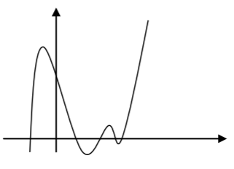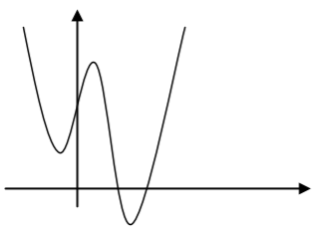

Polynomials

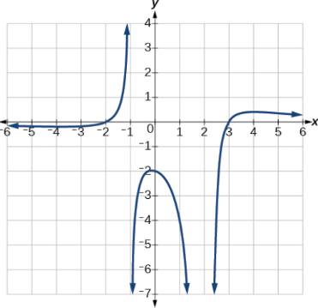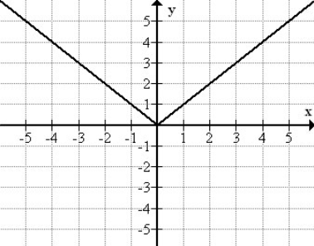

Not Polynomials

The **degree** of the polynomial is the highest power of the variable that occurs in the polynomial; it is the power of the first variable if the function is in general form.

The **leading term** is the term containing the highest power of the variable, or the term with the highest degree.

The **leading coefficient** is the coefficient of the leading term.

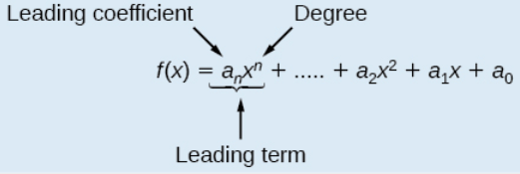

Examples: For the following polynomials, identify the degree, the leading term, and the leading coefficient.

$3+2x^{2}-4x^{3}$

$5t^{5}-2t^{3}+7t$

$6p-p^{3}-2$

# Characteristics of Polynomial Functions

**Many of the characteristics previously discussed about functions also occur in polynomial functions. For instance:**

**Relative/Local Maximum:** Where the graph changes from increasing to decreasing.

**Relative/Local Minimum:** Where the graph changes from decreasing to increasing.

**Absolute/Global Maximum:** The highest point on the graph.

**Absolute/Global Minimum:** The lowest point on the graph.

$x$**-intercept(s):** Where the graph crosses the $x$-axis.

$y$**-intercept(s):** Where the graph crosses the $y$-axis.

**Turning Point:** a point at which the graph changes direction from increasing to decreasing or decreasing to increasing. Polynomials can have multiple turning points! The maximum number of turning points a polynomial can have is one less than the degree.

**End behavior:** Describes the behavior of the function to the far right and far left of the graph, when $x$ is very large and $x$ is very large and negative (i.e., does the graph rise or fall?). Knowing the degree and leading coefficient can help us determine how the graph will behave:

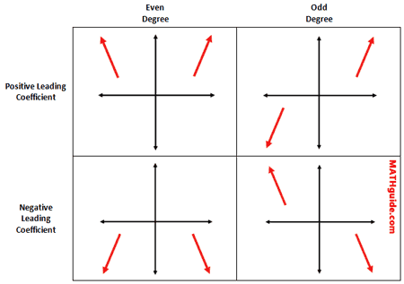

Examples:

1. An open-top box is to be constructed by cutting out squares from each corner of a 14 cm by 20 cm sheet of plastic and then folding up the sides. Find the size of squares that should be cut out to maximize the volume enclosed by the box.
2. Describe the end behavior and determine a possible degree of the polynomial function.

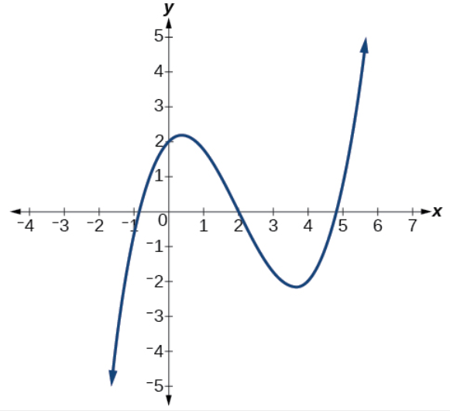

# End Behavior Notation

To describe the behavior as numbers become larger and larger, we use the idea of infinity. When we say that “ $x$ approaches infinity,” which can be symbolically written as $x→∞$, we are describing a behavior; we are saying that $x$ is increasing without bound.

The behavior of the graph of a function as the input values get very small $(x→-∞)$ and get very large $(x→∞)$ is referred to as the **end behavior** of the function. In symbolic form, we write

As $x→∞ \left(\text{on the right}\right), y=f\left(x\right)→∞ \left(\text{rises}\right) or-∞ (\text{falls})$

As $x→-∞ (\text{on the left}), y=f\left(x\right)→∞ \left(\text{rises}\right) or-∞ (\text{falls})$

We can use words or symbols to describe end behavior.

Examples:

1. Given the following graphs, determine if the degree is even or odd and if the leading coefficient is positive or negative. Then determine the end behavior using the correct notation.

a)

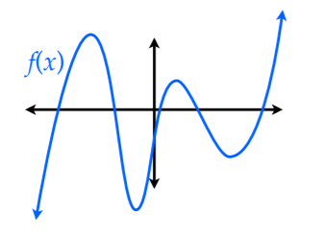

Degree: even or odd

Leading Coefficient: positive or negative

As $x→∞, f(x)→$

As $x→-∞, f(x)→$

b)

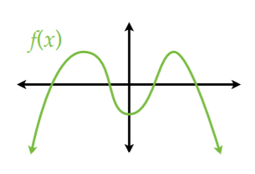

Degree: even or odd

Leading Coefficient: positive or negative

As $x→∞, f(x)→$

As $x→-∞, f(x)→$

1. Given the following functions, determine the degree, leading coefficient, the possible number of turning points and the end behavior *without* using the graph.

| Function | Degree | Leading Coefficient | Maximum # of turning points | End Behavior |
| --- | --- | --- | --- | --- |
| $$f\left(x\right)=4x^{7}+5x^{4}+2$$ |  |  |  | As $x→∞, f(x)→$ As $x→-∞, f(x)→$ |
| $$f\left(x\right)=-7x^{6}+2x^{2}-3x$$ |  |  |  | As $x→∞, f(x)→$ As $x→-∞, f(x)→$ |
| $$f\left(x\right)=-2x^{5}-x^{3}+2x^{2}$$ |  |  |  | As $x→∞, f(x)→$ As $x→-∞, f(x)→$ |